Kevin “Darcy” Fitzgerald Reflection – NT Japanese Professional Development Day 26.2.21
The 2021 NT Japanese Professional Development (PD) Day offered me many fantastic opportunities as an early career teacher. The PD Day saw numerous language and cultural organisations collaborate to promote Japanese language pedagogical strategies, ideas and resources. Attendees were most fortunate to have the expertise of the Japan Foundation present to update us on contemporary Japanese cultural trends as well as highlight the wealth of resources available through the Japan Foundation. The “golden nugget” that they offered me was a collection of short stories in hiragana which is accessible to all beginner learners. This resource was coupled with the strategy of tadoku, which roughly translates to “wide reading” or reading often.
Gems such as this was the theme of the day. Every presenter offered a new strategy, idea or resource. I discovered new excursion opportunities to better engage learners. Numerous fun, accessible and appropriate resources were revealed to me, along with contemporary lesson topics. Perhaps the most beneficial experience for me was the opportunity to see native speakers model their pedagogy. As a non-native speaker, it was great to see the type of language, actions and engagement used by these experienced teachers from all over the NT and Japan as well.
So far in my first few years of teaching, this has been the most practical, applicable and enjoyable PD I have attended. Thank you to LTANT, DLC, AJANT and the Japan Foundation for organising this amazing opportunity.

Japan Foundation PD Day, Darwin, 26 February 2021

Report by Brenda Austen Alice Springs Language Centre

Overall, the PD was fantastic!

I know how important it is for us teachers to be relevant, to deliver lessons that keep students motivated and to design meaningful lessons and assessment tasks. As a very busy teacher, I am often frustrated that I do not have time to keep up with the latest trends in Japan and to explore how we might incorporate contemporary trends and concepts into our teaching, especially when our students are already ahead of us and aware of popular trends such as “Demon Slayer”!

The session on the concept of “wa” resonated with me because it is multi-layered, ie we can develop an understanding of important elements of Japanese culture while learning words, kanji and make clear connections within language.

Kabuki neck exercises also great for combining manageable movement in the classroom that is actually embedded in the rich and historical culture of Kabuki.

The session on cup noodle was great because cup noodle is such a popular and well-known international brand that our students will have experienced. The activities were engaging, creative, fun and varied for the multi-level classroom.

Students sometimes feel overwhelmed by learning hiragana and want to give up. Teaching through Tadoku is a wonderful way to help students develop a sense of “I can do it” and a sense of accomplishment, from a young age.

Other hugely valuable aspects of the PD was being able to meet with other Japanese teachers and learn about their everyday practice, challenges and successes. The PD provided the opportunity to do this in structured sessions, such as introduction session (where we paired with another teacher and talked about why we became Japanese teachers and the highlights of our teaching career), as well as informally at lunch and at the dinner. At the dinner on Friday night we celebrated our hard work and the value of what we contribute as Japanese teachers!

Many thanks to the Japan Foundation and LTANT for bringing us together for this valuable learning and sharing. Especially for us from Alice Springs, as we don’t get the opportunity to take time out to refresh our teaching with new ideas and trends and to celebrate and share experiences with other Japanese teachers. Also many thanks for the wonderful posters.

I would also like to express my gratitude to Darwin Language Centre for hosting and catering the event and Ms Yumiko Shaw for her coordination and support.

Brenda Austen
Alice Springs Language Centre.

Japan Foundation Japanese P.D. - Reflection
Kiyo Goble

Northern Territory Japanese Professional Development Day on the 26th of February
At Darwin Language Center
Presenters: Himi Negishi-Wood, Minako Kadoi (Japan Foundation, Sydney)
Yumiko Shaw (NT DoE, LTANT & AJANT)

First session, all Northern Territory teachers found a partner, Japanese introduction.
My partner was Darwin Middle School Japanese teacher (Australian) and we introduced each other in Japanese, we discussed why we started teaching Japanese in Australia.
After introduction, the representatives from Japan Foundation from Sydney gave presentations.
The content was on 3 major economic impacts last year in Japan, such as Anime Movie “Daemon Slayer”, Matcha – green tea, Kao-moji, Kabuki dance, and the history and 50 years of celebration of instant cup noodles.
We teachers were divided in small groups and discussed how to plan using those Japanese trends in our lessons. We shared unique ideas such as teaching Japanese adjectives with Kao-moji etc.

Second session we divided into two groups – Primary and middle, and Secondary school teachers.
I joined the Secondary school group and learned “Collaborative Writing”.
The idea was to write an article - for Japanese high school magazine about some of the events held at school that year.
After writing a draft we swapped with peer - read, analyzed, revised and evaluated the peer’s draft.
The creative task was to fill in the bubbles in 4 frames of a cartoon and write a story in Japanese and then share with a pair. It was an interesting creative task and we could share many different stories in class and the task made good connection between us and lifted up to a higher order thinking skill.

Lastly we shared our school’s teaching ideas, I gave presentation about “Making o-bento in 2020” with middle school students. Learning language through cooking made a natural language learning environment for both teachers and students. Our students were all engaged and enthusiastic to use Japanese words with teachers.

In conclusion, I learned some classroom activity ideas from other teachers that used updated trends in Japanese education to engage students. On the other hand I miss traditional Japanese teaching ideas, such as basic hiragana teaching methods with flash cards or language games or origami activities. I currently teach middle school classes with an Australian teacher so I am able to teach authentic Japanese manners. It is important to teach those Japanese leaners to reflect or realize different care and respect especially with regard to Japanese style of manners.

Kiyo Goble

LTANT Japanese PD Day in Darwin 2021
Reflection Akane Tschirpig
Iam glad to attend the Japanese PD Day on Friday 26 February 2021.This PD was divided into three sessions, exploring the concept of 和(Harmony), Learning hiragana through “tadoku”(For Primary and Middle school teachers)and activity ideas based on a familiar theme.
After the main sessions, we also had a discussion and share ideas about the community involvements to promote Japanese Language program in Northern Territory. We were introduced recent trends in Japan and ideas on how teachers can incorporate Japanese culture into the language program. We also explored ways to foster classroom activities using Japanese culture such as movie, food, and Traditional Japanese art. What I found it very interesting of participating this PD was the Learning hiragana through “tadoku(多読)”by Himi Negishi-Wood who from the Japan Foundation,Sydney.
In Japanese language, there are three different writing scripts and teaching the basic hiragana is a big challenge in a limited amount lesson for early year. “ta(多)”means ‘a lot and “doku(読)means ‘to read’. During this session, we clarified and analysed the mechanism of tadoku. It was meaningful to discuss with other teachers about further applications of tadoku and effective way to retaining hiragana in our classrooms.
Thank you to LATNT for organising such a great PD! 鱇鲏鱑鱭鱋鱙鱛鱉鲃鱜鱤。

Reflection Mariko Japanese PD Day 26 Feb 2021
This PD introduced teachers about current popular topics in Japan and how to utilise them in classrooms. Such information is quite useful as it can be very difficult to catch up or see trends and changes in Japan from Australia. The introduced contents and strategy were useful. However, exchanging ideas with NT teachers about how to adjust the teaching strategies well-suited to our contexts make us ready to use them. Activities such as cooking/ making Australian own recipe with Japanese ingredients can be challenging in this COVID situation. COVID safe arrangement would be needed, but it can be great joint/shared activity for sister school/ Tomodachi connect project. Resources introduced by Japan Foundation such as 4 koma-manga as well as strategies for collaborative work can enrich language learning and develop team work skills.
It also good to see example practice from primary/junior school as well as senior level. It was a great opportunity to meet Japanese Language teachers in different schools and levels, and to strengthen our network.

Ryoko Jones

Japanese PD Day was very informative, helpful and very well organised.
The presenters were extremely professional.
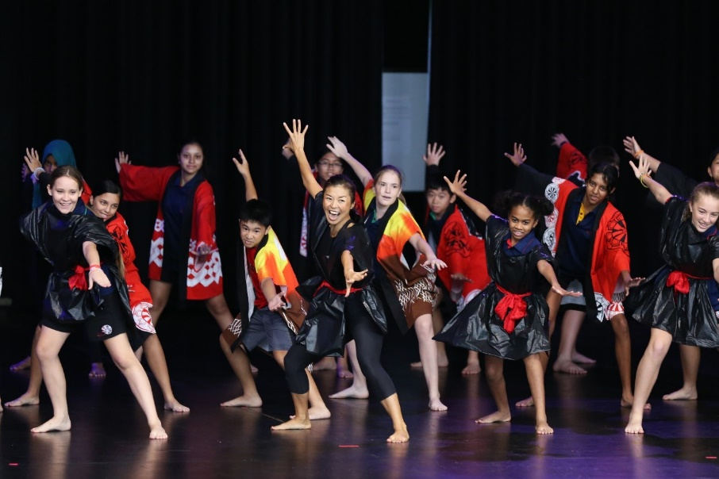
Sharing teaching ideas with fellow Japanese teachers was also helpful. I have utilised the ‘garbage bag ninja costume’ for our Soran bushi dancers at Harmony Day assembly. (Please see attached)
I left Japan 20 years ago so learning current Japanese trend was an eye-opener. I liked presentation on Japanese cup noodles with a variety of cooking options. Thank you very much again for the amazing PD.

